**PRACTICAL 1 – Basic I/O Programs**

**AIM:**

To write basic I/O Programs

**Theory:**

**Introduction:** C++ is an object-oriented programming language. It was developed by Bjarne Stroustrup at AT&T Bell Laboratories in Murray Hill, New Jersey, USA, in the early 1980’s. C++ is a superset of C. Most of what we already know about C applies to C++ also. Therefore, almost all C programs are also C++ programs. However, there are a few minor differences that will prevent a C program to run under C++ compiler.

**Advantages:** Portability, Mid-level programming language, Object-Oriented, Multi-paradigm programming language, Memory management.

**Disadvantages:** Pointers, No garbage collection, unsafe, Complex, No custom operators, No built-in threads, lack of algebraic data types.

**Applications:** C++ is widely used in operating systems, browsers, libraries, banking applications, Cloud systems, many databases and compilers for other languages also use C++ as backend, Embedded systems.

**Header file:** Header files contain definitions of Functions and variables which is imported or used into any C++ program.

**Functions:** A function in C++ is a group of statements that together perform a specific task. Every C/C++ program has at least one function that the name is main. The **main function** is called by the operating system by which our code is executed. We can make n number of function in a single program but we can make only one **main function** in a single program. Every program has only one main function.

**Datatypes:**

* **Built-in:**
* **Integral Type**
  + Int
  + Char
* **Floating type**
* Float
* Double
* **User-Defined:**
  + Structure
  + Union
  + Class
  + Enumeration
* **Derived type:**
  + Array
  + Function
  + Pointer
  + Reference

**Q1: Write a program in C++ to print the sum of two numbers entered by user.**

**CODE:**

#include <iostream>

using namespace std;

int main()

{

int a, b, c;

cout << "\nEnter two numbers: ";

cin >> a >> b;

c = a + b;

cout << "\nSum of two numbers = " << c;

return 0;

}

**OUTPUT:**

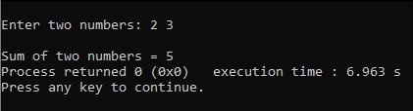

**Fig1. Output for C++ program to print the sum of two numbers entered by user.**

**Q2. Write a program in C++ to find size of fundamental data types**

**CODE:**

#include <iostream>

using namespace std;

int main()

{

cout << "\nSize of int is " << sizeof(int);

cout << "\nSize of int is " << sizeof(float);

cout << "\nSize of int is " << sizeof(char);

cout << "\nSize of int is " << sizeof(double);

}

**OUTPUT:**

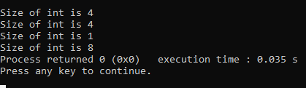

**Fig2. Output for C++ program to find size of fundamental data types.**

**Q3. Write C++ program to swap two numbers entered by user.**

**CODE:**

#include <iostream>

using namespace std;

int main()

{

int a, b, temp;

cout << "\nEnter value of a and b: ";

cin >> a >> b;

cout << "\nBefore swap a = " << a << " and b = " << b;

temp = a;

a = b;

b = temp;

cout << "\nAfter swap a = " << a << " and b = " << b;

}

**OUTPUT:**

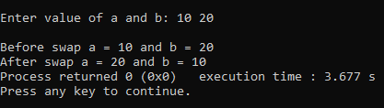

**Fig3. Output for C++ program to swap two numbers entered by user**

**Q4. Write C++ program to calculate the volume of a cube**

**CODE:**

#include <iostream>

#include <math.h>

using namespace std;

int main()

{

int a, b;

cout << "\nEnter side of a cube: ";

cin >> a;

b = pow(a, 3);

cout << "\nVolume of cube = " << b;

}

**OUTPUT:**

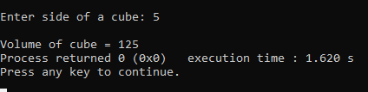

**Fig4. Output for C++ program to calculate the volume of a cube**